Support Ohio H.B. 725: Prohibit Commercial Dog Breeders from Performing Surgical Procedures on Puppies and Dogs Without Pain Medication or Anesthesia

Ohio H.B. 725, sponsored by Representatives Lanese and Hoops and co-sponsored by Reps. Brinkman, Carruthers, Denson, Adam Miller, Schmidt, and Tom Young, will eliminate the conflict in the interpretation of “surgical procedures” between regulations (OAC 901:1-6-05) promulgated by the Ohio Department of Agriculture (ODA) and the Ohio Revised Code. H.B. 725 will provide clear and concise boundaries regarding the performance of surgical and dental procedures on a canine by clearly prohibiting a person, other than a licensed veterinarian, from performing these procedures on a dog.

Puppy Mill Animals are Subjected to Inhumane Surgical Procedures
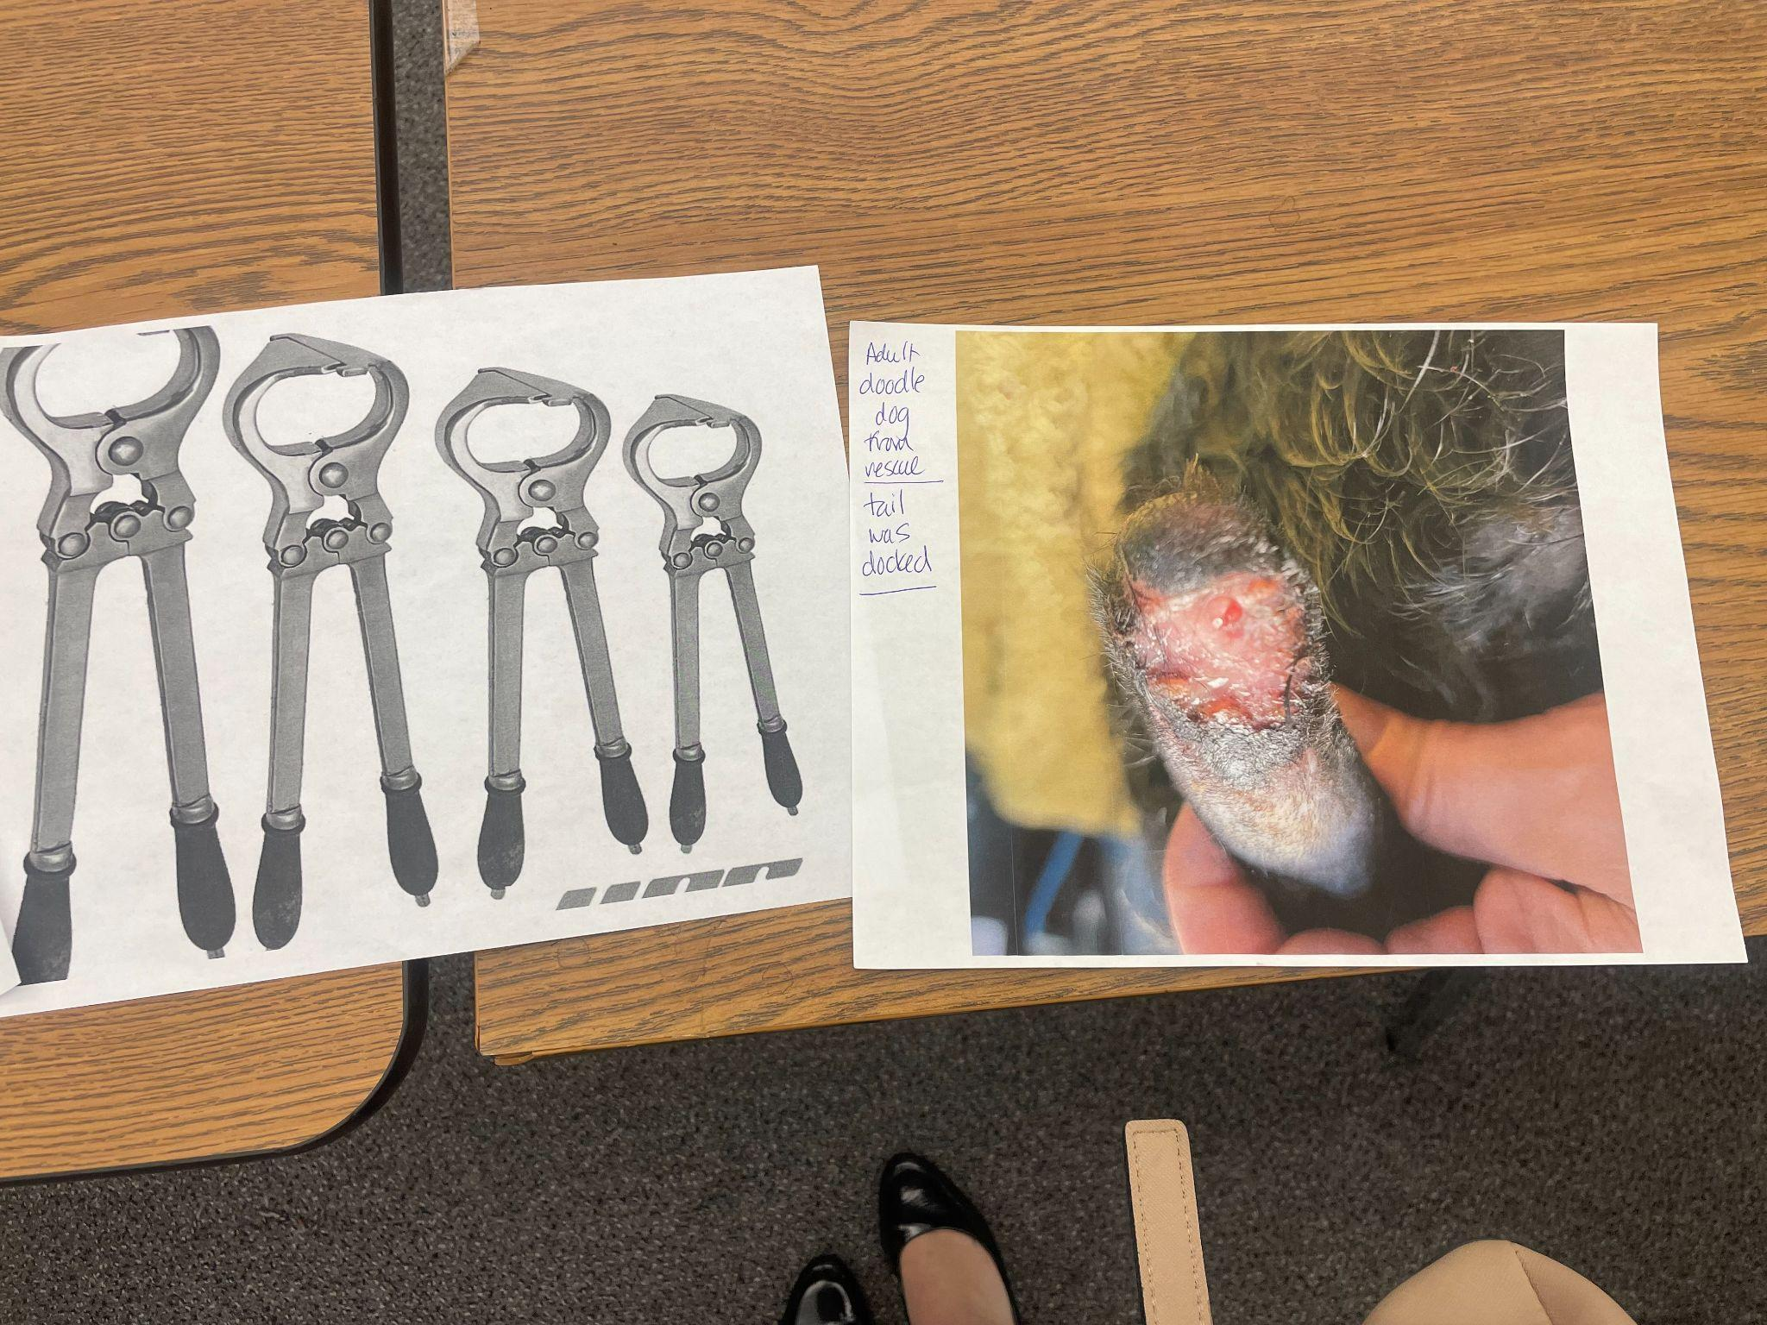
Allowing a person to perform “at-home” surgical procedures on an animal without proper pain management and anesthesia, would be considered animal cruelty, torture, and torment in violation of ORC 959.131-B. ODA lacks the authority to enact regulations that allow anyone other than veterinarians to conduct such surgical procedures.

Future Risks Associated with Improper Surgeries

Improper surgical procedures can result in the prolonged suffering of puppies and dogs. Commercial dog breeders do not possess the proper training to perform surgeries on animals. Amateur “at-home” surgical procedures can result in painful infections, permanent injuries, and even death. When these animals are sold to families, their medical history can yield costly operations to fix botched surgeries. Operations are not only emotionally draining to the family – they can create tremendous financial strife for Ohio pet owners.

What You Can Do to Help
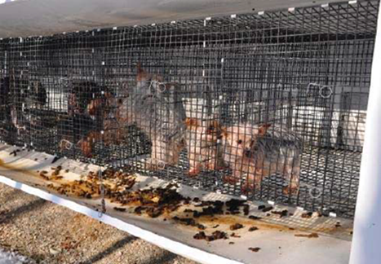
Reach out to your Ohio state representatives and urge them to support Ohio H.B. 725, using Ohio Animal Advocates action alert (link). HSUS’s 2021 Horrible Hundred report lists Ohio as having 16 of the nation’s worst 100 puppy mills (link). Ohio H.B. 725 is critical to protect innocent animals from amateur surgical procedures.

Horrific Real Life Animal Welfare Violations
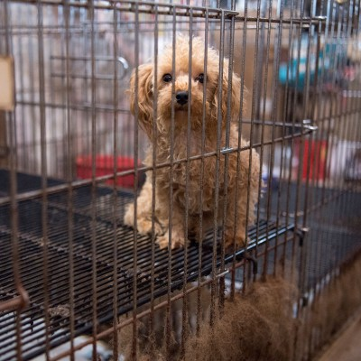
As reported in the HSUS 2021 Horrible Hundred, Joseph A. Miller performed one of the worst instances of a "do-it-yourself" dental procedure at Horseshoe Kennel. Inspectors found that Miller performed an “at-home” dental procedure, which resulted in the death of a female Yorkshire terrier. The inspection report notes: "Licensee stated that this dog died during her dental cleaning, and stated the dog seemed stressed when [restrained], and he could see there was root exposure." The horrific treatment of a dog with such advanced dental disease, who was not sedated or given adequate pain control to calm her down, should never have happened. The tragic incident highlights a need for Ohio H.B. 725 to clarify that only veterinarians are to perform surgical procedures on canines.

